Keil Software Working



Step1: Click for KEIL μVISION4 Icon. Which appearing after Installing Keil KEIL μVISION4.

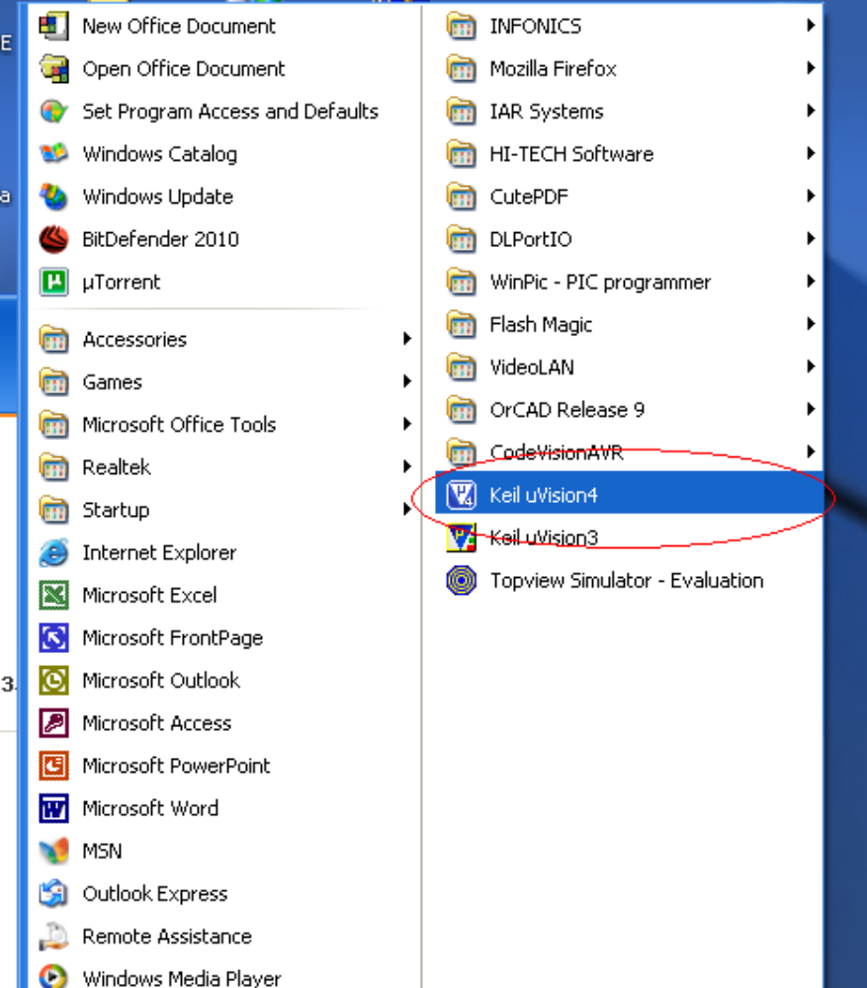

Step2: Click on Project Menu, Then New μVison Project.
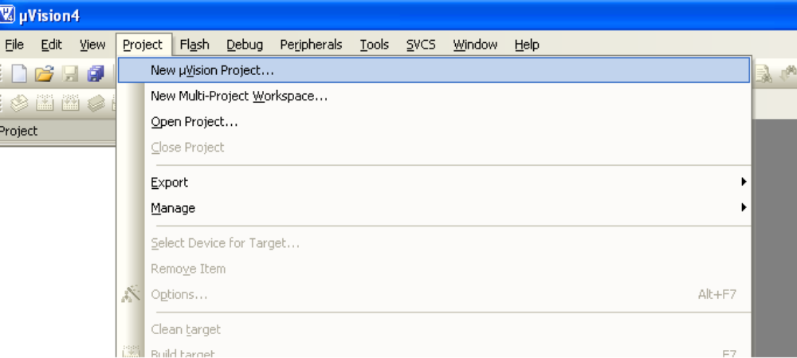
Step3: Create New Project Folder named as “Keil Test”.

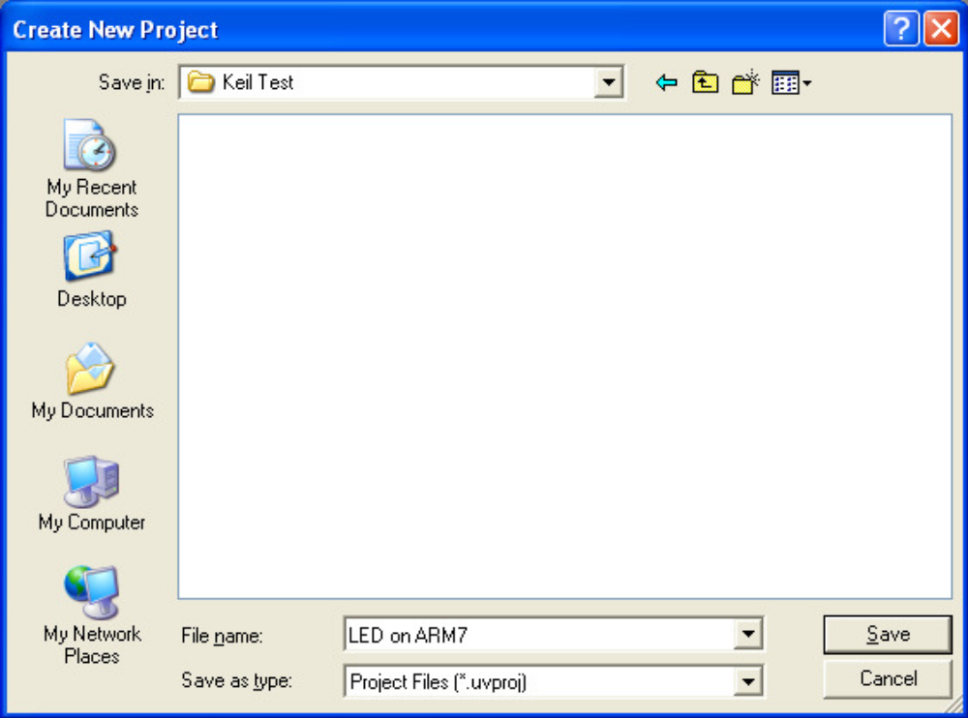

Step 4: Select Target Device Vendor (i.e.).
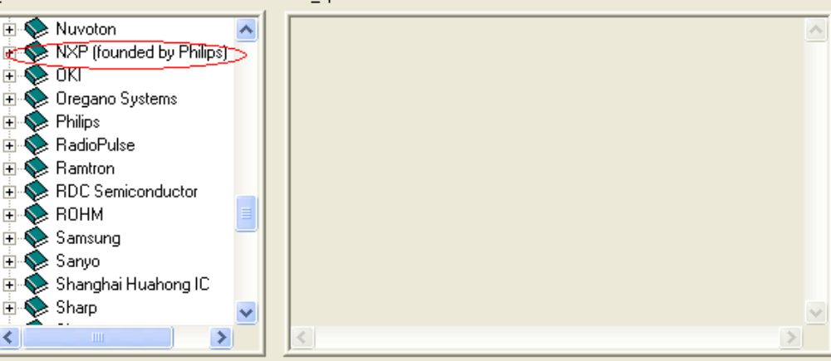
Step 5: Then select specific chip LPC2148.
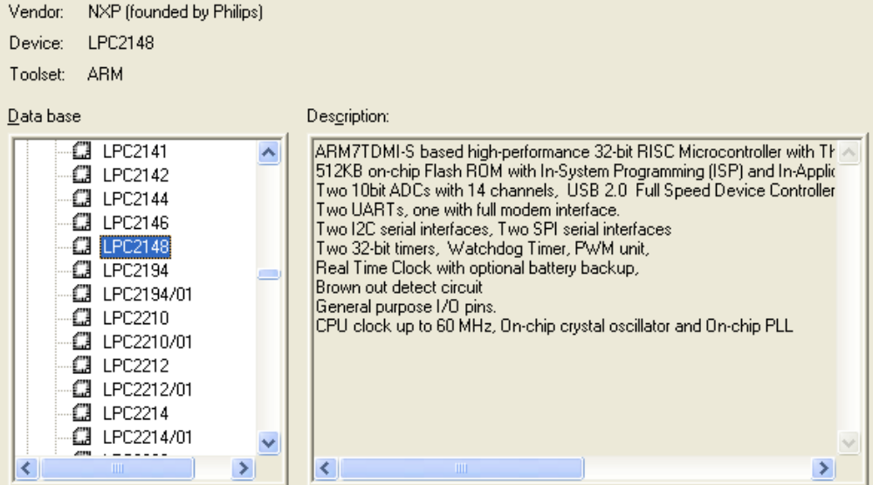
Step 6: Then select specific chip i.e. LPC2148.
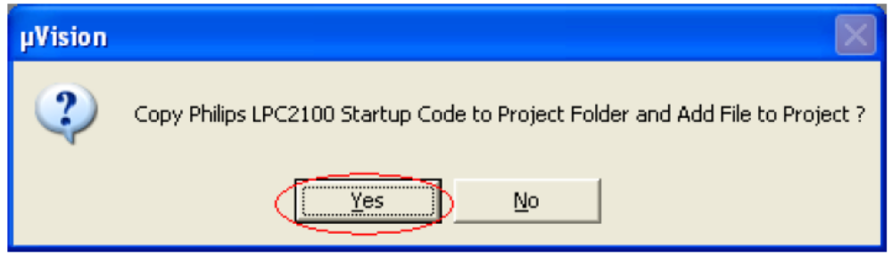
Step 7: Then you will see following window.
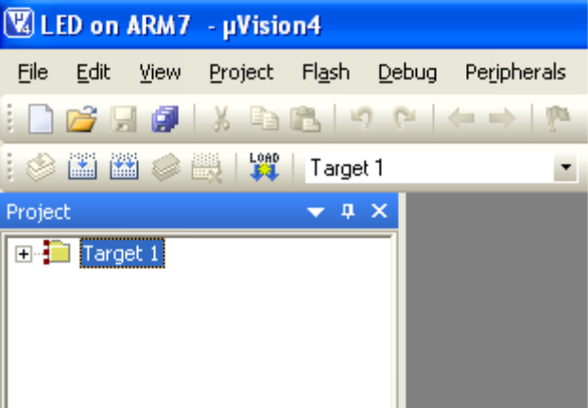
Step 8: Now you see Startup.s is already added which is necessary for running code for
Keil.
Note: Code wills Not Run without Startup.s
Startup.s is available in C:\Keil\ARM\Startup\Philips.
The startup-code executes immediately upon reset of the target system and performs the
following operations:
1. Defines interrupt and exception vectors.
2. Configures the CPU clock source (on some devices).
3. Initializes the external bus controller.
4. Copies the exception vectors from ROM to RAM for systems with memory
remapping.
5. Initializes other low level peripherals, if necessary.
6. Reserves and initializes the stack for all modes.
7. Reserves the heap.
8. Transfers control to the main C function.
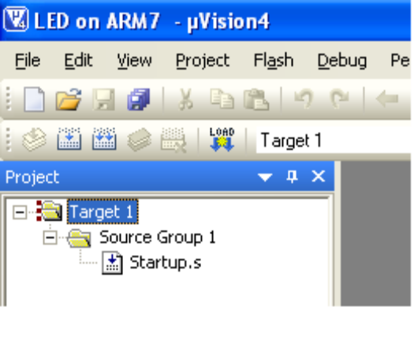
Step 9: Now Click on File Menu and Click on New.
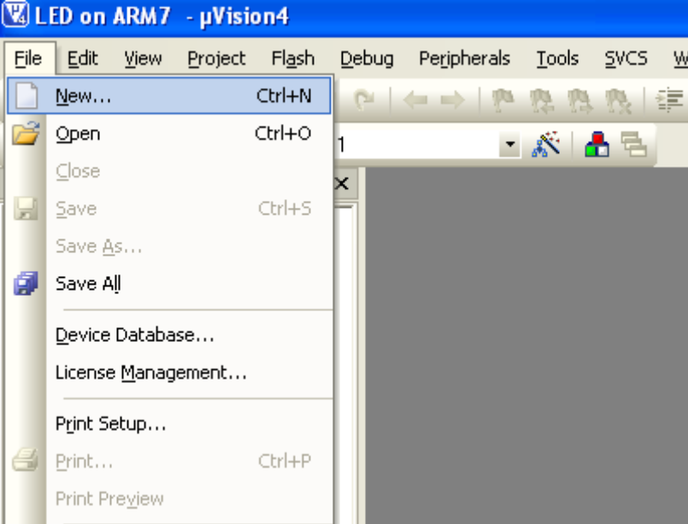
Step 10: Write Code for Blink LED in C and FileName.c Save.
Note: Don’t forget to save .c Extension.
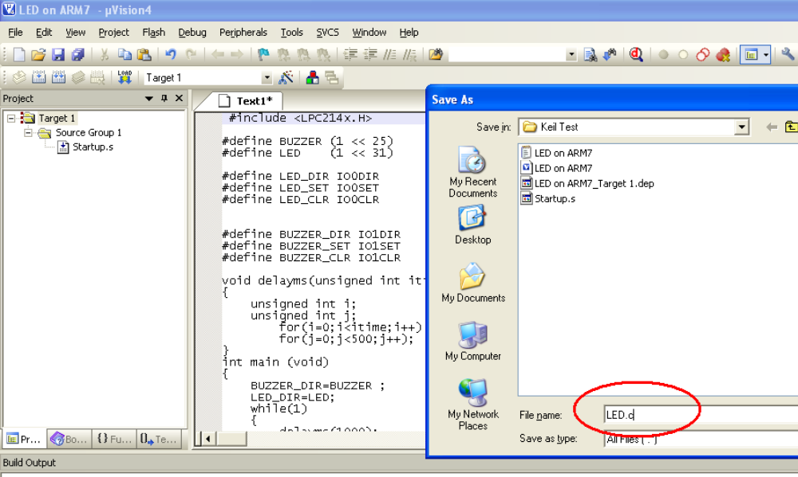
Step 11: Now you Window in C Syntax.
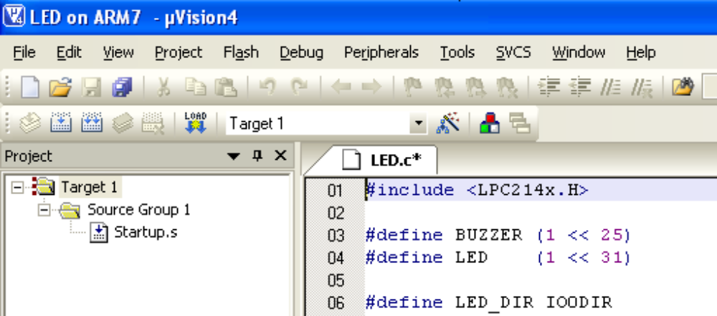
Step 12: Now you add LED.c file by adding Sourse Group 1 Add files to Group ‘Source Group 1’.

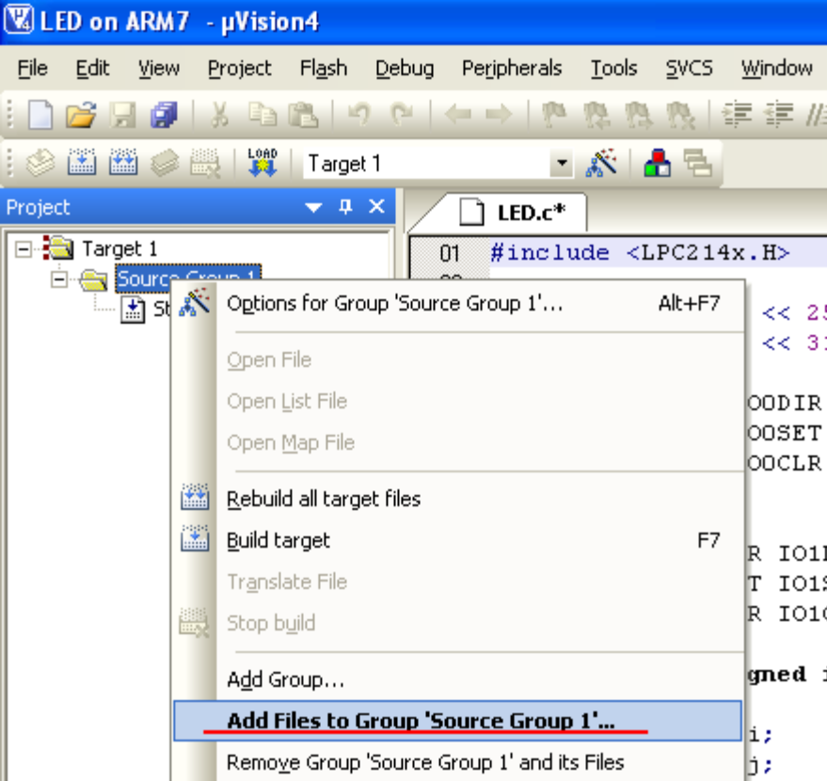
Step 13: Add LED.C file.
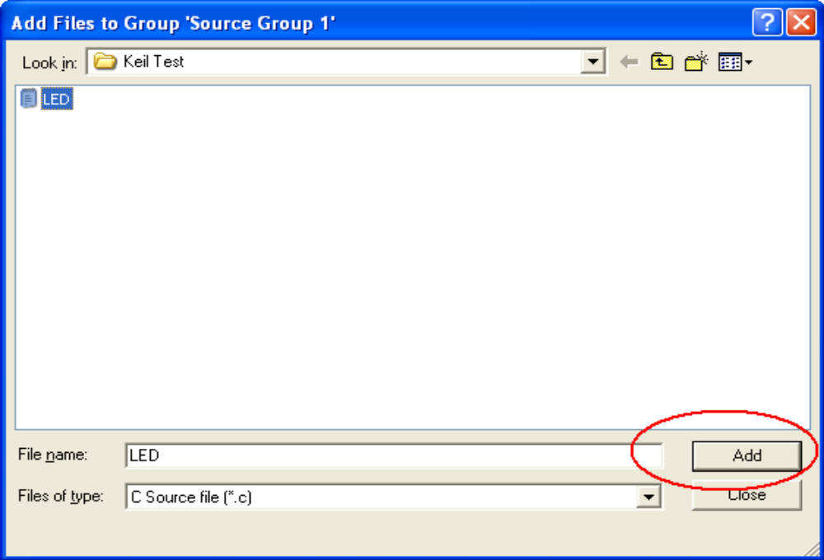

Step 14: Now Click on Options for Target ‘Target 1’.
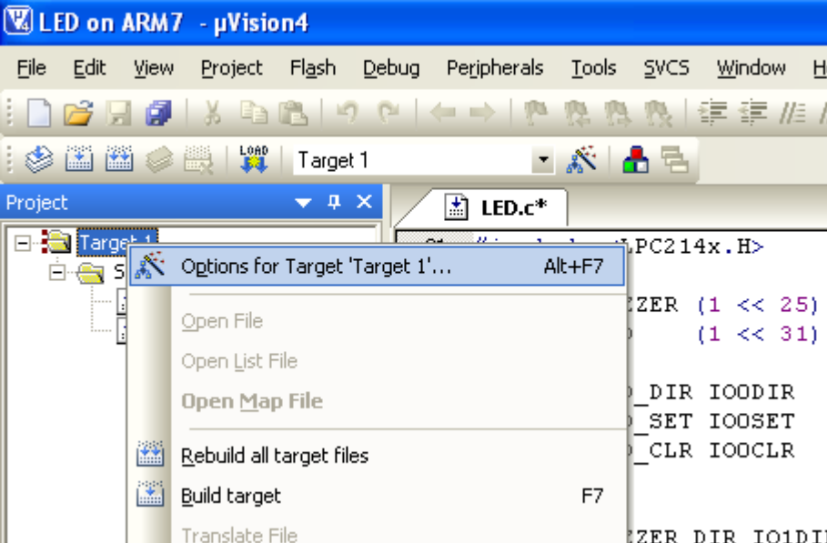

Step 15: Go to Options for Target ‘Target 1’. Click on Check Box Create HEX File.
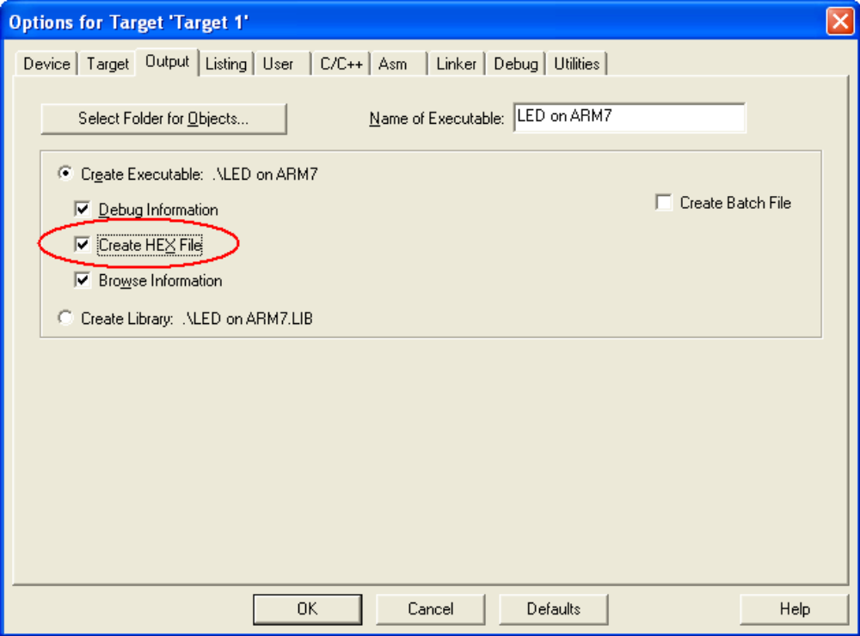
Step 16: Then go to Linker. Click on Use Memory Layout for Target Dialog.
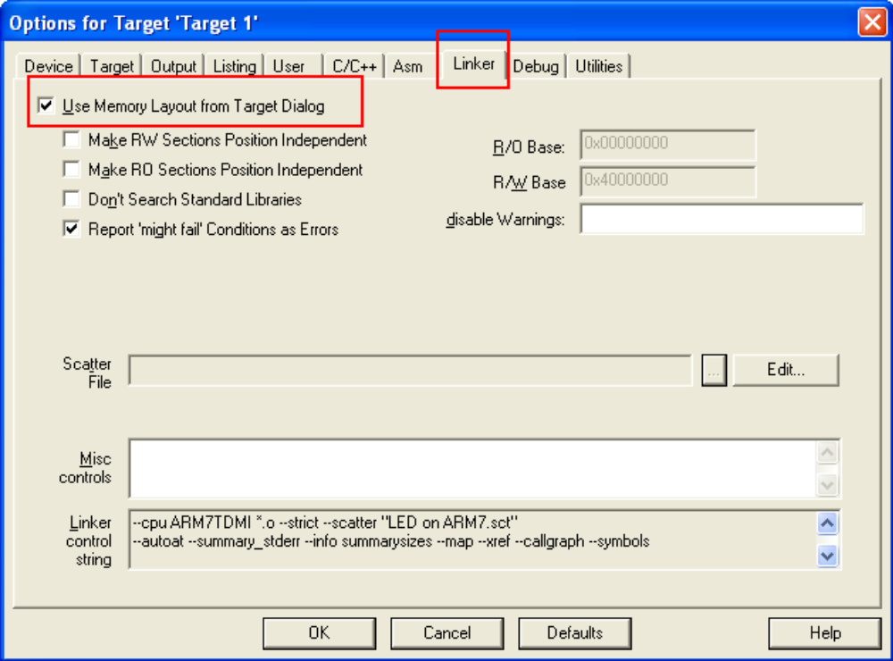

Step 16: Then Click on Rebuild All Target Files
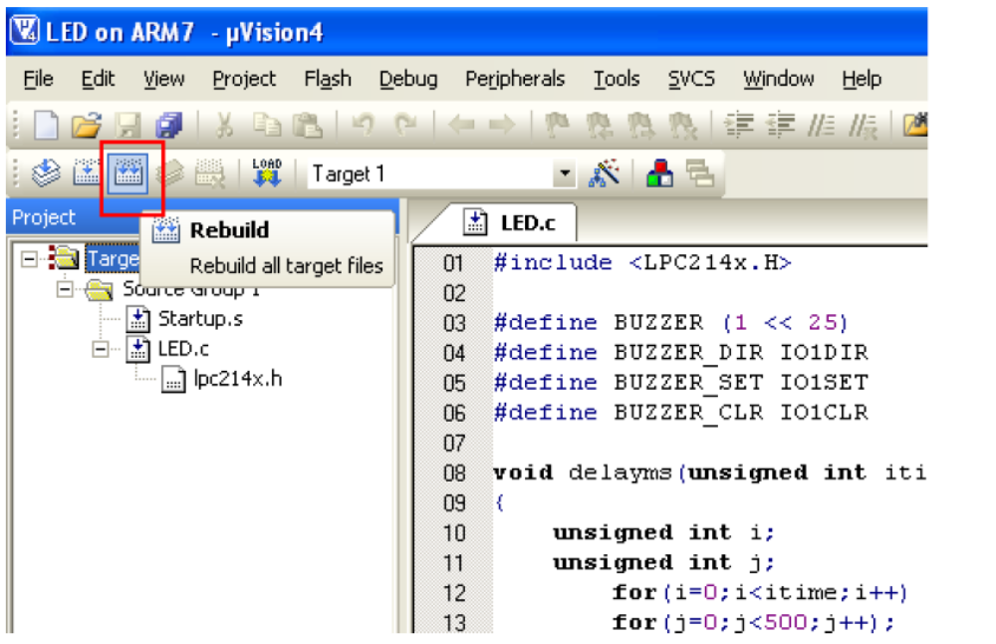
Step 17: Now you see 0 Error(s), 0 Warning (s). Then Hex File will create in Specific Folder. Now to download it for you target hardware.

Code

CONCLUSION

The project “” has been successfully designed and tested. It has been developed by integrating features of all the hardware components used. Presence of every module has been reasoned out and placed carefully thus contributing to the best working of the unit.
Secondly, using highly advanced IC’s and with the help of growing technology the project has been successfully implemented.
Finally we conclude that EMBEDDED SYSTEM is an emerging field and there is a huge scope for research and development

BIBLIOGRAPHY

References on the Web:
- www.national.com
- www.atmel.com
- www.microsoftsearch.com
- www.geocities.com
- www.alldatasheets.com
- www.arm.com
- www.armfreaks.net
- www.armdesign.com
- www.microcontrollershop.com
- www.ultrasonicdirectory.com
- ARM Micro Controller – Steven F. Barrett, Daniel J.Pack

